DOCKER PROJECT
STEP-1: LAUNCH AN INSTANCE WITH T2.LARGE AND EBS 30
STEP-2: INSTALL JENKINS, GIT, DOCKER & TRIVY
STEP-3: INSTALL THE FOLLOWING JENKINS PLUGINS
SONAR SCANNER
NODEJS
OWASP DEPENDENCY CHECK
DOCKER PIPELINE
Eclipse Temurin installerVersion
Pipeline stage view
STEP-4: CONFIGURE ALL THE PLUGINS INTO JENKINS
STEP-5: WRITE A PIPELINE
TRIVY INSTALLATION:
wget https://github.com/aquasecurity/trivy/releases/download/v0.18.3/trivy_0.18.3_Linux-
64bit.tar.gz
tar zxvf trivy_0.18.3_Linux-64bit.tar.gz sudo mv trivy /usr/local/bin/
vim .bashrc
export PATH=$PATH:/usr/local/bin/ source .bashrc
JENKINS INSTALLATION:
amazon-linux-extras install java-openjdk11 -y sudo wget -O /etc/yum.repos.d/jenkins.repo https://pkg.jenkins.io/redhatstable/jenkins.repo
sudo rpm --import https://pkg.jenkins.io/redhat-stable/jenkins.io-2023.key yum install jenkins -y systemctl start jenkins
GIT & DOCKER INSTALLATION:
yum install git docker -y systemctl start docker chmod 777 ///var/run/docker.sock
SETUP SONAR USING DOCKER:
docker run -d --name sonar -p 9000:9000 sonarqube:lts-community
After creating the sonar container, access the sonarqube with 9000 port number.
Login to the sonar dashboard with the following and credentials
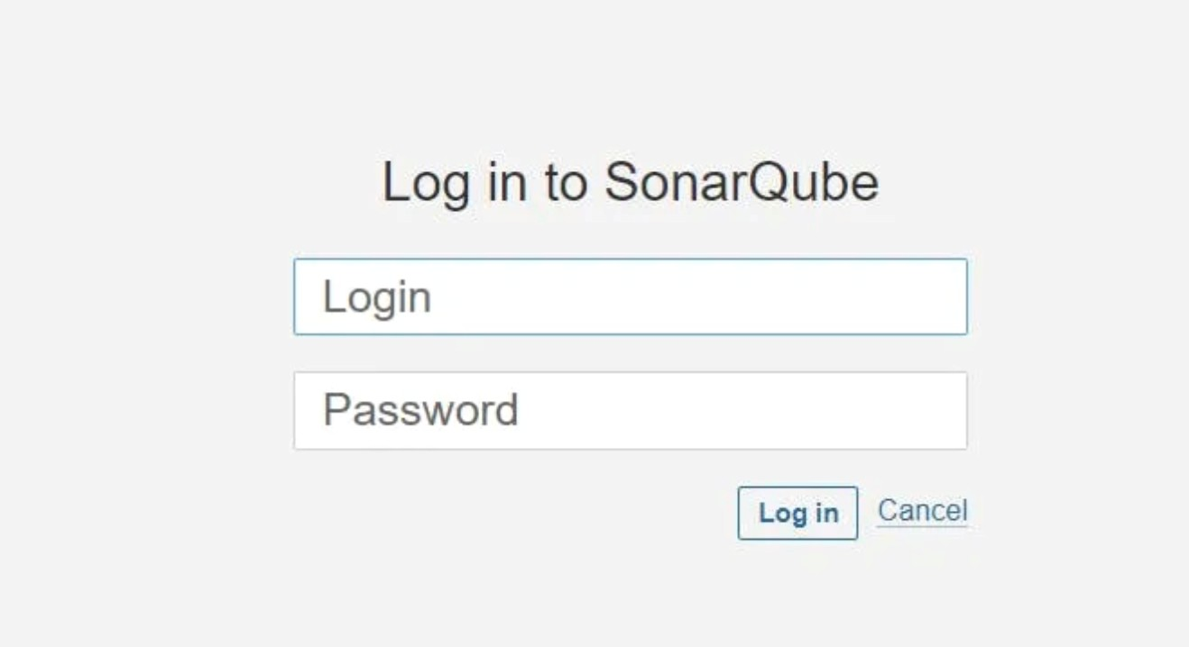
username: admin
password: admin
After entering the credentials we have to set a new password.
CONFIGURE ALL THE PLUGINS INTO JENKINS:
Goto your Sonarqube Server. Click on Administration ---→ Security ---→ Users → Click on Tokens and Update Token ---→ Give it a name ---→ and click on Generate Token.
copy Token
Goto Jenkins Dashboard ---→ Manage Jenkins ---→ Credentials ---→ Add Secret Text with id sonar-token.
Goto Jenkins Dashboard → Manage Jenkins → Credentials → Add Secret Text.
Add sonarqube.
Now, go to Dashboard --→ Manage Jenkins ----→ System and Add sonar servers with the name of mysonar – > url: http://ip:9000/ – > token – save
Click on Apply and Save
The Configure option is used in Jenkins to configure different server.
Click on add SonarQube Scanner in TOOLS Section Name: mysonar
click on install automatically and proceed with default version.
In the Sonarqube Dashboard add a quality gate also
Administration → Configuration →Webhooks
Click on Create
Name: Jenkins
URL: <http://jenkins-public-ip:8080>/sonarqube-webhook/
Now configure NodeJs, Java & DP-Check
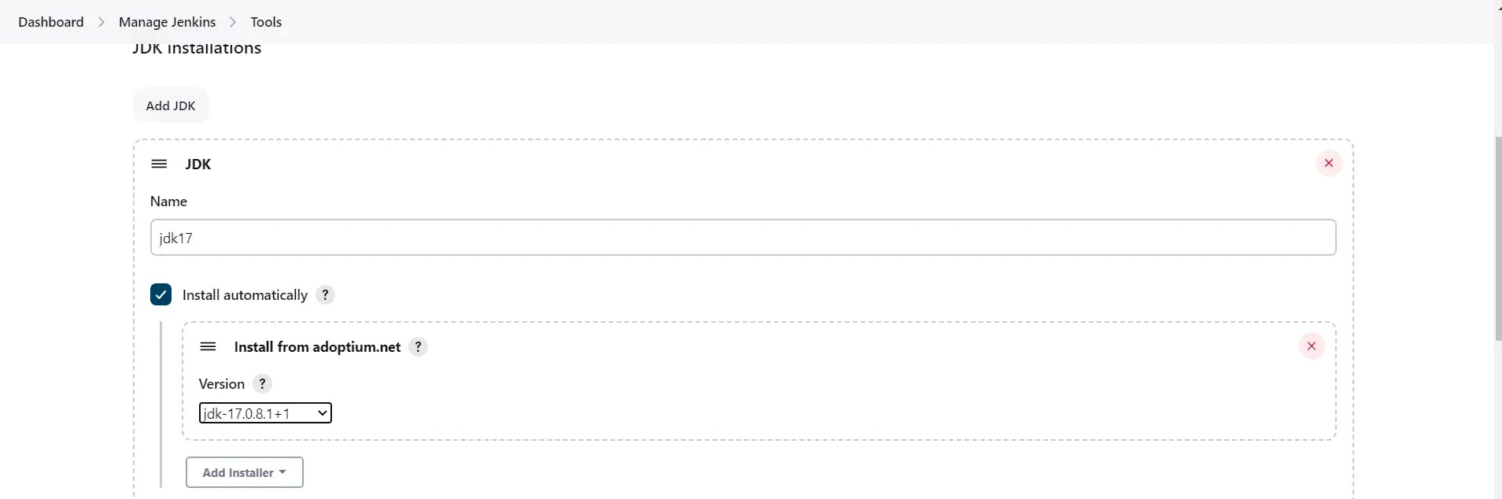
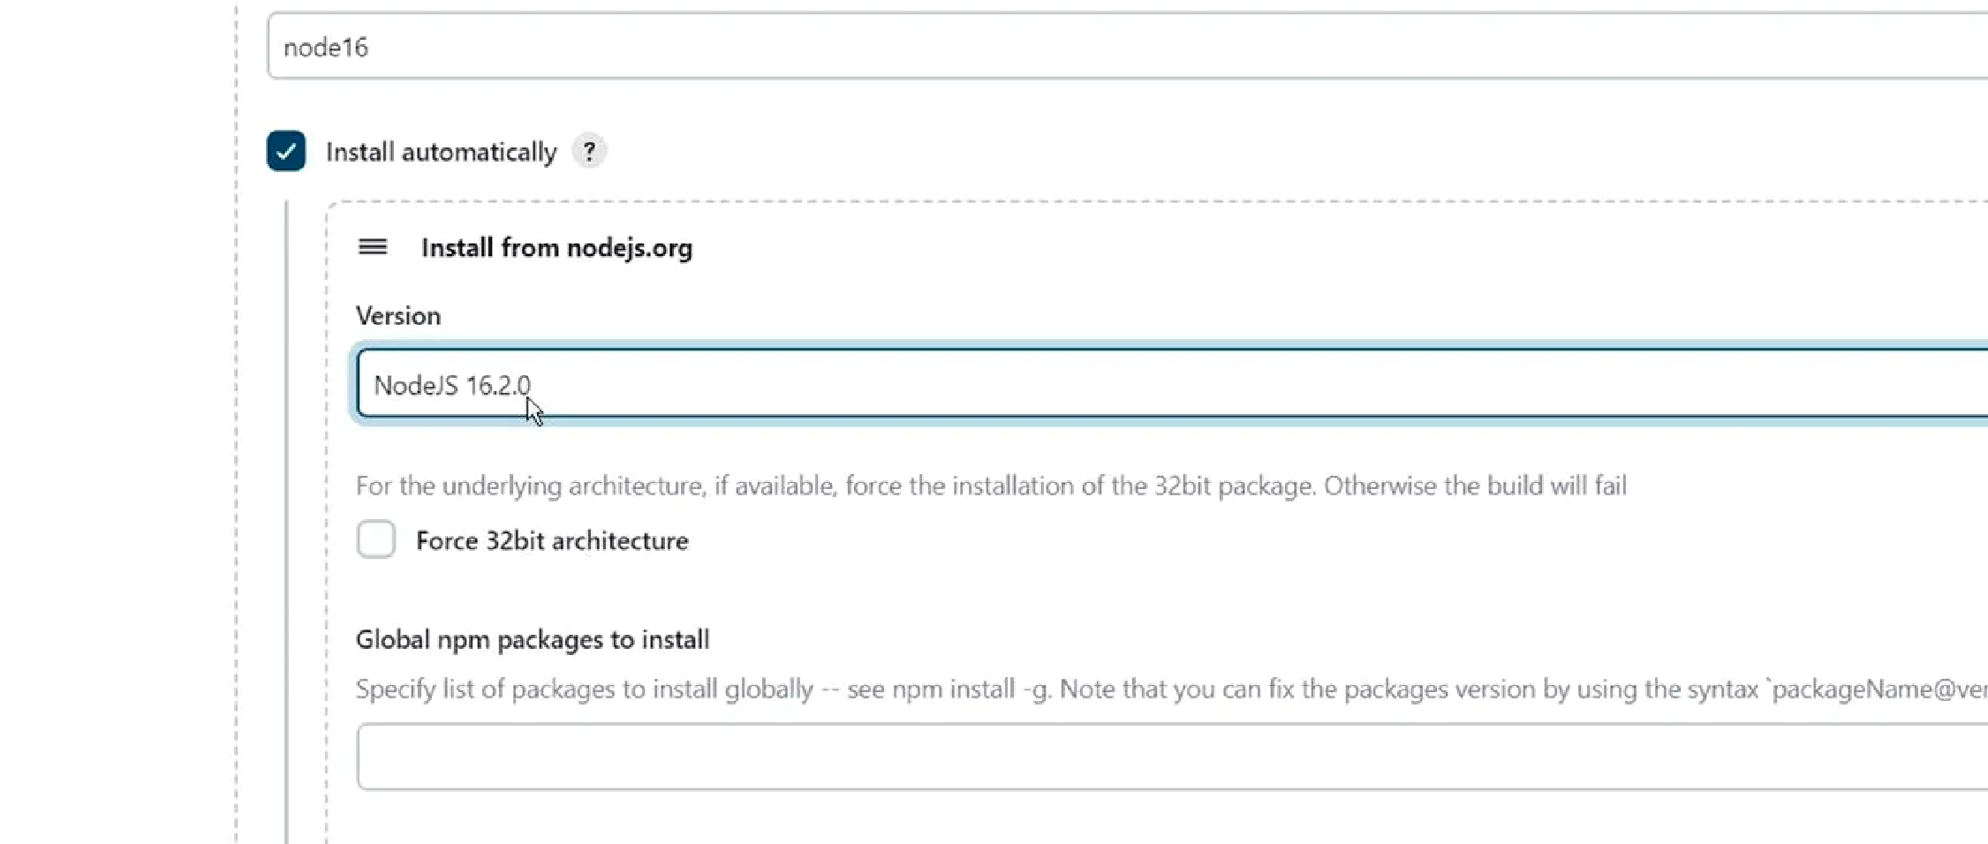
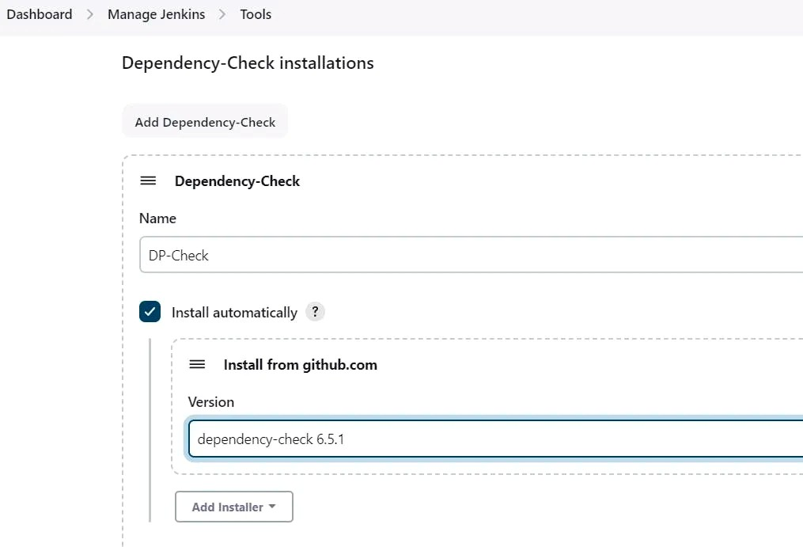
Click on Apply and Save here.
START WRITING DECLARATIVE PIPELINE:
pipeline {
agent any tools { jdk 'jdk17' nodejs 'node16'
}
environment {
SCANNER_HOME = tool 'mysonar'
}
stages { stage("Clean WS") {
steps { cleanWs()
}
}
stage("Code") {
steps {
git “https://github.com/devops0014/Zomato-Project.git”
}
}
stage("Sonarqube Analysis") {
steps {
withSonarQubeEnv('mysonar') { sh """$SCANNER_HOME/bin/sonar-scanner \
-Dsonar.projectName=zomato \
-Dsonar.projectKey=zomato"""
}
}
}
stage("Quality Gates") {
steps { script {
waitForQualityGate abortPipeline: false, credentialsId: 'sonar-token'
}
}
}
stage("Install Dependencies") {
steps { sh 'npm install'
}
}
stage("OWASP") {
steps {
dependencyCheck additionalArguments: '--scan ./ --disableYarnAudit -disableNodeAudit', odcInstallation: 'DP-Check' dependencyCheckPublisher pattern: '**/dependency-check-report.xml'
}
}
stage("Trivy") { steps { sh 'trivy fs . > trivyfs.txt'
}
}
stage("Build") { steps { sh 'docker build -t image1 .'
}
}
stage("Tag & Push") {
steps { script {
withDockerRegistry(credentialsId: 'docker-password') { sh 'docker tag image1 shaikmustafa/mydockerproject:myzomatoimage' sh 'docker push shaikmustafa/mydockerproject:myzomatoimage'
}
}
}
}
stage("Scan the Image") {
steps {
sh 'trivy image shaikmustafa/mydockerproject:myzomatoimage'
}
}
stage("Container") {
steps {
sh 'docker run -d --name cont1 -p 3000:3000 shaikmustafa/mydockerproject:myzomatoimage'
}
}
}
}
